**Modelagem e Matemática II – Laboratório 9**

**Exercício 1.a)**

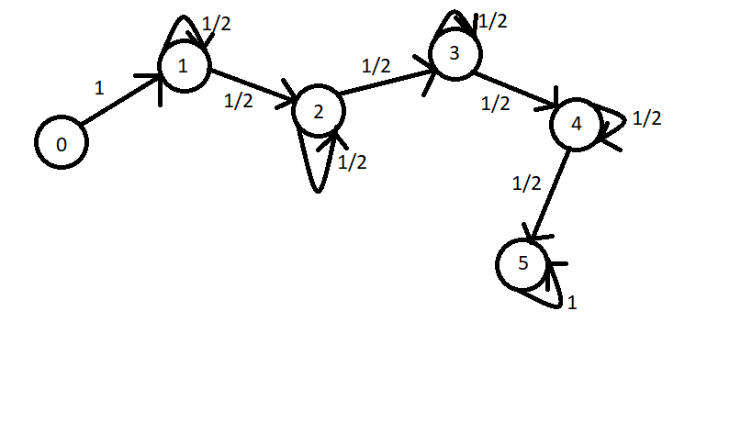

E = {0, 1, 2, 3, 4, 5}

E0 = {0}

**Matriz**

[0] [1] [2] [3] [4] [5]

[0] 0 1 0 0 0 0

[1] 0 0.5 0.5 0 0 0

[2] 0 0 0.5 0.5 0 0

[3] 0 0 0 0.5 0.5 0

[4] 0 0 0 0 0.5 0.5

[5] 0 0 0 0 0 1

**b)** **P2 =**

[0] [1] [2] [3] [4] [5]

[0] 0 0.5 0.5 0 0 0

[1] 0 0.25 0.5 0.25 0 0

[2] 0 0 0.25 0.5 0.25 0

[3] 0 0 0 0.25 0.5 0.25

[4] 0 0 0 0 0.25 0.75

[5] 0 0 0 0 0 1

**P5 =**

[0] [1] [2] [3] [4] [5]

[0] 0 0.0625 0.25 0.375 0.25 0.0625

[1] 0 0.03125 0.15625 0.3125 0.3125 0.1875

[2] 0 0 0.03125 0.15625 0.3125 0.5

[3] 0 0 0 0.03125 0.15625 0.8125

[4] 0 0 0 0 0.03125 0.96875

[5] 0 0 0 0 0 1

**P10 =**

[0] [1] [2] [3] [4] [5]

[0] 0 0.001953125 0.017578125 0.0703125 0.1640625 0.7460938

[1] 0 0.0009765625 0.009765625 0.0439453125 0.1171875 0.828125

[2] 0 0 0.0009765625 0.009765625 0.0439453125 0.9453125

[3] 0 0 0 0.0009765625 0.009765625 0.9892578

[4] 0 0 0 0 0.0009765625 0.9990234

[5] 0 0 0 0 0 1

**P20 =**

[0] [1] [2] [3] [4] [5]

[0] 0 1.907349e-06 3.623962e-05 3.261566e-04 1.848221e-03 0.9977875

[1] 0 9.536743e-07 1.907349e-05 1.811981e-04 1.087189e-03 0.9987116

[2] 0 0 9.536743e-07 1.907349e-05 1.811981e-04 0.9997988

[3] 0 0 0 9.536743e-07 1.907349e-05 0.9999800

[4] 0 0 0 0 9.536743e-07 0.9999990

[5] 0 0 0 0 0 1